

MOBILE PHONE SELLING SITE

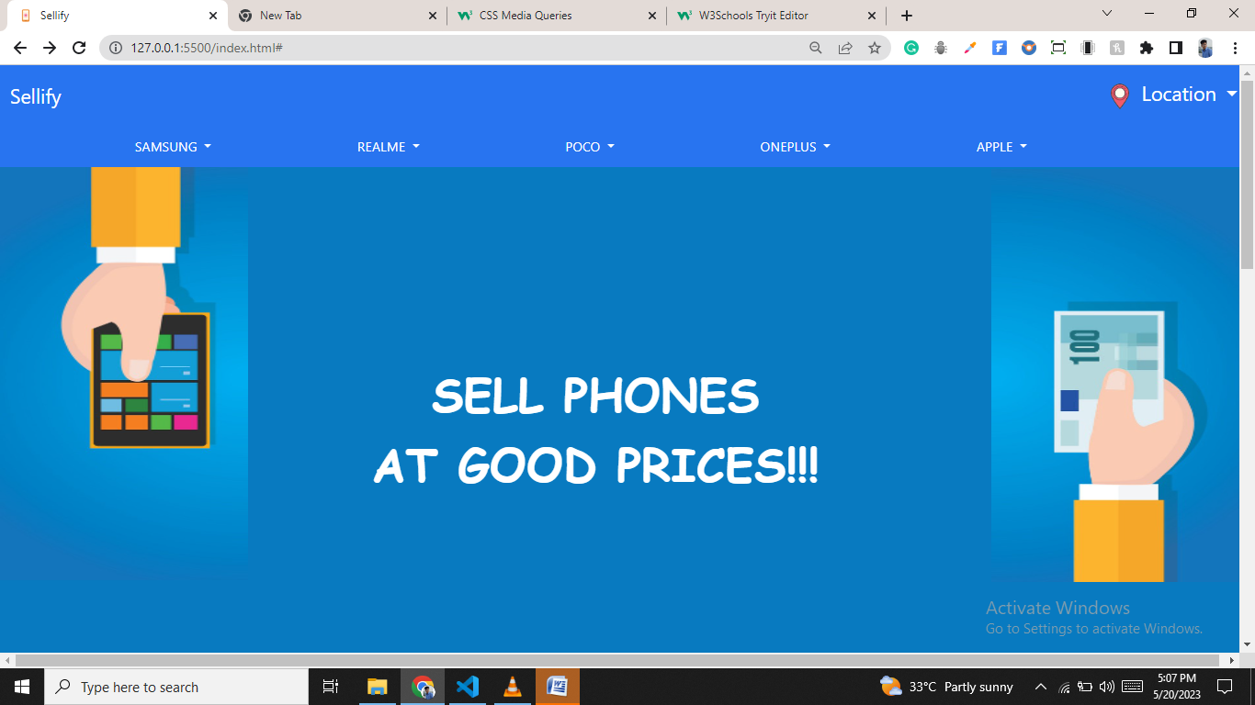

MOBILE PHONE SELLING SITE

Guided by: by Surendar Thinakaran S

Panneer Selvam

**Abstract:**

The project “Mobile Phone selling site” is dynamic website helps us to sell old mobiles on online, check your old phone price and sells it to current price of the market.

**Modules:**

* Home
* Phone Mistakes
* Address Page

**SOFTWARE**

**1.HTML**

* HTML stands for Hyper Text Markup Language
* HTML is the standard markup language for creating Web pages
* HTML describes the structure of a Web page
* HTML consists of a series of elements
* HTML elements tell the browser how to display the content
* HTML elements label pieces of content such as "this is a heading", "this is a paragraph", "this is a link", etc.

**2.CSS**

* CSS stands for Cascading Style Sheets
* CSS describes how HTML elements are to be displayed on screen, paper, or in other media
* CSS saves a lot of work. It can control the layout of multiple web pages all at once
* External stylesheets are stored in CSS files

**3.JAVASCRIPT**

JavaScript is the **Programming Language** for the Web.

JavaScript can update and change both **HTML** and **CSS.**

JavaScript can **calculate**, **manipulate** and **validate** data.

**4.JQUERY**

* jQuery is a lightweight, "write less, do more", JavaScript library.
* jQuery takes a lot of common tasks that require many lines of JavaScript code to accomplish, and wraps them into methods that you can call with a single line of code.
* jQuery also simplifies a lot of the complicated things from JavaScript, like AJAX calls and DOM manipulation.

Tools have used: Visual studio

Source code

* HTML:

<!DOCTYPE html>

<html lang="en">

<head>

    <meta charset="UTF-8">

    <meta http-equiv="X-UA-Compatible" content="IE=edge">

    <meta name="viewport" content="width=device-width, initial-scale=1.0">

    <title>Booking</title>

    <link rel="icon" type="image/x-icon" href="favicon/airplane.ico">

    <link rel="stylesheet" href="style.css">

    <!-- Latest compiled and minified CSS -->

<link href="https://cdn.jsdelivr.net/npm/bootstrap@5.2.3/dist/css/bootstrap.min.css" rel="stylesheet">

<!-- Latest compiled JavaScript -->

<script src="https://cdn.jsdelivr.net/npm/bootstrap@5.2.3/dist/js/bootstrap.bundle.min.js"></script>

<script src="https://ajax.googleapis.com/ajax/libs/jquery/3.6.4/jquery.min.js"></script>

</head>

<body>

<nav id="nav1" class="navbar navbar-expand-lg navbar-light">

        <div class="container-fluid">

          <a class="navbar-brand" href="#">Sellify</a>

          <!-- <button class="navbar-toggler" type="button" data-bs-toggle="collapse" data-bs-target="#navbarNavDropdown" aria-controls="navbarNavDropdown" aria-expanded="false" aria-label="Toggle navigation">

            <span class="navbar-toggler-icon"></span>

          </button>-->

          <div class="collapse navbar-collapse" id="navbarNavDropdown">

            <div class="collapse navbar-collapse justify-content-end">

            <ul  id="navitem-location" class="navbar-nav navitem-location">

                <li class="nav-item dropdown">

                    <a class="nav-link dropdown-toggle" href="#" id="navbarDropdownMenuLink" role="button" data-bs-toggle="dropdown" aria-expanded="false">

                      <img src="src/loc.png" width="40px" alt="loc"> <span id="loctxt">Location</span>

                    </a>

              <ul id="Location-dd" class="dropdown-menu list-navbar Location-dd"  aria-labelledby="navbarDropdownMenuLink">

                <li><a onclick="loc1()" id="Chennai" href="#">Chennai</a></li>

                <li><a onclick="loc2()" id="Coimbatore" href="#">Coimbatore</a></li>

                <li><a onclick="loc3()" id="Madurai" href="#">Madurai</a></li>

                <li><a onclick="loc4()" id="Tiruchirappalli" href="#">Tiruchirappalli</a></li>

                <li><a onclick="loc5()" id="Tirunelveli" href="#">Tirunelveli</a></li>

                <li><a onclick="loc6()" id="Kanchipuram" href="#">Kanchipuram</a></li>

                <li><a onclick="loc7()" id="Vellore" href="#">Vellore</a></li>

                <li><a onclick="loc8()" id="Tiruvannamalai" href="#">Tiruvannamalai</a></li>

                <li><a onclick="loc9()" id="Cuddalore" href="#">Cuddalore</a></li>

                <li><a onclick="loc10()" id="Sriperumbudur" href="#">Sriperumbudur</a></li>

              </ul>

              </li>

            </ul>

          </div>

        </div></div>

      </nav>

      <!-- navbar2 -->

      <div id="nav2" class="navbar navbar-expand-lg navbar-light">

        <div class="dropdown">

          <button class="btn  dropdown-toggle" type="button" id="dropdownMenuButton1" data-bs-toggle="dropdown" aria-expanded="false">

            SAMSUNG

          </button>

          <ul id="Samsung" class="dropdown-menu" aria-labelledby="dropdownMenuButton1">

              <li><a href="page2.html">Samsung Galaxy S21 Ultra</a></li>

              <li><a href="page2.html">Samsung Galaxy S21 Plus</a></li>

              <li><a href="page2.html">Samsung Galaxy S21</a></li>

              <li><a href="page2.html">Samsung Galaxy Note 20 Ultra</a></li>

              <li><a href="page2.html">Samsung Galaxy Note 20</a></li>

              <li><a href="page2.html">Samsung Galaxy S20 Ultra</a></li>

              <li><a href="page2.html">Samsung Galaxy S20 Plus</a></li>

              <li><a href="page2.html">Samsung Galaxy S20</a></li>

              <li><a href="page2.html">Samsung Galaxy Note 10 Plus</a></li>

              <li><a href="page2.html">Samsung Galaxy Note 10</a></li>

              <li><a href="page2.html">Samsung Galaxy S10 Plus</a></li>

              <li><a href="page2.html">Samsung Galaxy S10</a></li>

            </ul>

        </div>

        <div class="dropdown">

          <button class="btn dropdown-toggle" type="button" id="dropdownMenuButton2" data-bs-toggle="dropdown" aria-expanded="false">

            REALME

          </button>

          <ul class="dropdown-menu" aria-labelledby="dropdownMenuButton2">

              <li><a href="page2.html">Realme 8 Pro</a></li>

              <li><a href="page2.html">Realme 8</a></li>

              <li><a href="page2.html">Realme Narzo 30 Pro</a></li>

              <li><a href="page2.html">Realme Narzo 30A</a></li>

              <li><a href="page2.html">Realme 7 Pro</a></li>

              <li><a href="page2.html">Realme 7</a></li>

              <li><a href="page2.html">Realme X7 Pro</a></li>

              <li><a href="page2.html">Realme X7</a></li>

              <li><a href="page2.html">Realme 6 Pro</a></li>

              <li><a href="page2.html">Realme 6</a></li>

              <li><a href="page2.html">Realme C15</a></li>

              <li><a href="page2.html">Realme C12</a></li>

            </ul>

        </div>

        <div class="dropdown">

          <button class="btn dropdown-toggle" type="button" id="dropdownMenuButton3" data-bs-toggle="dropdown" aria-expanded="false">

            POCO

          </button>

          <ul class="dropdown-menu" aria-labelledby="dropdownMenuButton3">

              <li><a href="page2.html">Poco X3 Pro</a></li>

              <li><a href="page2.html">Poco X3 NFC</a></li>

              <li><a href="page2.html">Poco M3 Pro 5G</a></li>

              <li><a href="page2.html">Poco M3</a></li>

              <li><a href="page2.html">Poco X2</a></li>

              <li><a href="page2.html">Poco X2 Pro</a></li>

              <li><a href="page2.html">Poco F3</a></li>

              <li><a href="page2.html">Poco F2 Pro</a></li>

              <li><a href="page2.html">Poco X</a></li>

              <li><a href="page2.html">Poco C3</a></li>

            </ul>

        </div>

        <div class="dropdown">

          <button class="btn dropdown-toggle" type="button" id="dropdownMenuButton4" data-bs-toggle="dropdown" aria-expanded="false">

            ONEPLUS

          </button>

          <ul class="dropdown-menu" aria-labelledby="dropdownMenuButton4">

              <li><a href="page2.html">OnePlus 9 Pro</a></li>

              <li><a href="page2.html">OnePlus 9</a></li>

              <li><a href="page2.html">OnePlus Nord 2 5G</a></li>

              <li><a href="page2.html">OnePlus Nord CE 5G</a></li>

              <li><a href="page2.html">OnePlus 8T</a></li>

              <li><a href="page2.html">OnePlus 8 Pro</a></li>

              <li><a href="page2.html">OnePlus 8</a></li>

              <li><a href="page2.html">OnePlus 7T Pro</a></li>

              <li><a href="page2.html">OnePlus 7T</a></li>

              <li><a href="page2.html">OnePlus 7 Pro</a></li>

              <li><a href="page2.html">OnePlus 7</a></li>

            </ul>

        </div>

        <div class="dropdown">

          <button class="btn dropdown-toggle" type="button" id="dropdownMenuButton5" data-bs-toggle="dropdown" aria-expanded="false">

            APPLE

          </button>

          <ul class="dropdown-menu" aria-labelledby="dropdownMenuButton5">

              <li><a href="page2.html">iPhone</a></li>

              <li><a href="page2.html">iPhone 13</a></li>

              <li><a href="page2.html">iPhone 13 Pro</a></li>

              <li><a href="page2.html">iPhone 13 mini</a></li>

              <li><a href="page2.html">iPhone SE</a></li>

              <li><a href="page2.html">iPhone XR</a></li>

              <li><a href="page2.html">iPhone 11</a></li>

              <li><a href="page2.html">iPhone 11 Pro</a></li>

              <li><a href="page2.html">iPhone 11 Pro Max</a></li>

              <li><a href="page2.html">iPhone XS</a></li>

              <li><a href="page2.html">iPhone XS Max</a></li>

              <li><a href="page2.html">iPhone X</a></li>

              <li><a href="page2.html">iPhone 8</a></li>

            </ul>

        </div>

      </div>

      <div class="banner">

        <div>

        <img id="lefthandbanner" src="src/lefthandbanner.jpg" width="20%" height="500px" alt="">

        </div>

        <div ID="bannertxt"><p>SELL PHONES <BR>AT GOOD PRICES!!!</p></div>

<div><img id="righthandbanner" src="src/righthandbanner.jpg" width="20%" height="500px" alt="">

     </div>

    </div>

    <div id="spage">

      <div id="spage-content1">

        <p id="spage-c1-subcontent1">Sell Your Gadget in 3 Steps</p>

        <p id="spage-c1-subcontent2">Book a free pickup from your home or work<br> at a time slot as per your convenience</p>

      </div>

      <div class="row" id="spage2">

      <div class="col-xxl-4 col-xl-4"  id="spage-content2">

        <p id="spage-c2-subcontent1"><img width="30" height="30" src="https://img.icons8.com/color/30/price-tag--v1.png" alt="price-tag--v1"/>Check Price</p>

      <p id="spage-c2-subcontent2">Select your device & tell us about its current condition, and our advanced AI tech will tailor make the perfect price for you.</p>

      </div>

      <div  class="col-xxl-4 col-xl-4"  id="spage-content3">

        <p id="spage-c3-subcontent1"><img width="30" height="30" src="https://img.icons8.com/ios-filled/30/FAB005/marker.png" alt="marker"/>Schedule Pickup</p>

      <p id="spage-c3-subcontent2">Book a free pickup from your home or work at a time slot as per your convenience</p>

      </div>

      <div  class="col-xxl-4 col-xl-4" id="spage-content4">

        <p id="spage-c4-subcontent1"><img width="30" height="30" src="https://img.icons8.com/ios-glyphs/30/FAB005/money-bag.png" alt="money-bag"/>Get paid instantly</p>

      <p id="spage-c4-subcontent2">Did we mention you get paid as soon as our executive picks up your device? It’s instant & secure payment all the way!</p></div>

    </div></div>

    <div id="page3">

      <div class="row">

      <div class="col-xxl-6 col-xl-6" id="box-1">

        <p id="box-c1">5726.02 Cr.</p>

        <p id="box-c2">Cash Given</p>

      </div>

      <div  class="col-xxl-6 col-xl-6" id="box-2">

        <p id="box-c1">84.83 Lac</p>

        <p id="box-c2">Gadgets Encashed</p>

      </div></div>

      <div class="row">

      <div class="col-xxl-6 col-xl-6" id="box-3">

        <p id="box-c1">1.1 Lac</p>

        <p id="box-c2">Devices repaired</p>

      </div>

      <div class="col-xxl-6 col-xl-6" id="box-4">

        <p id="box-c1">4.5+</p>

        <p id="box-c2">User Rating</p>

      </div></div>

      <div id="rside-3page">

  <p  id="txt-after-boxes">Trusted by 76.37 Lac +<br>

Happy Users and Major Brands since 2015.

<p class="badge bg-primary">OUR PARTNERS</p>

</p>

      <img src="src/compaines.png" width="80%" alt="">

    </div></div>

    <div id="last-div">

      <hr>

      <p style="font-weight: 600;">Registered Office:</p>

      <p>Manak Waste Management Pvt Ltd.| B-39, 1st Floor, Middle Circle, Connaught Place, New Delhi-110001, India, Support-7290068900 | CIN: U27205DL2009PTC190441

Manak Waste Management Pvt Ltd. is ISO 27001 Compliance Certified. Person who may be contacted in case of any compliance related queries or grievances : Manoj Kumar(manoj.k@sellify.in)</p>

<p>** All product names, logos, and brands are property of their respective owners. All company, product and service names used in this website are for identification purposes only. Use of these names, logos, and brands does not imply endorsement.</p>

</div>

<div id="last-logo">

  <a target="_blank" href="https://www.apple.com/in/app-store/"><img src="src/app-logo.Jpg" width="10%" alt=""></a>

  <a target="_blank" href="https://play.google.com/store/games?utm_source=apac_med&utm_medium=hasem&utm_content=Oct0121&utm_campaign=Evergreen&pcampaignid=MKT-EDR-apac-in-1003227-med-hasem-py-Evergreen-Oct0121-Text_Search_BKWS-BKWS%7CONSEM_kwid_43700065205026376_creativeid_535350509654_device_c&gclid=CjwKCAjw9pGjBhB-EiwAa5jl3Ep8mrx8xaOHqIwZoHuxGAWRn1Dw0rkQI-gWkHDdsyF1YydeWm_uQhoCiGQQAvD_BwE&gclsrc=aw.ds"><img src="src/PLAY-logo.png" width="12%" alt=""></a>

</div>

Page 2.html

    <img src="src/phone.gif" id="phoneimg" height="500px" alt="">

    <div id="rb">

        <form action="" id="rbform">

        <p>1. Are you able to make and receive calls?</p>

        <label for="m/rcalls1">Yes</label>

        <input type="radio" name="radio-1" id="m/rcalls1">

        <label for="m/rcalls2">No</label>

        <input type="radio" name="radio-1" id="m/rcalls2">

        <p>2. Is your device's touch screen working properly?</p>

        <label for="ds1">Yes</label>

        <input type="radio" name="radio-2" id="ds1">

        <label for="ds2">No</label>

        <input type="radio" name="radio-2" id="ds2">

        <p>3. Is your phone's screen original?</p>

        <label for="pso">Yes</label>

        <input type="radio" name="radio-3" id="pso">

        <label for="pso2">No</label>

        <input type="radio" name="radio-3" id="pso2">

        <p>4. Is your device under brand warranty?</p>

        <label for="dub">Yes</label>

        <input type="radio" name="radio-4" id="dub1">

        <label for="dub2">No</label>

        <input type="radio" name="radio-4" id="dub2">

        <p>5. Do you have valid bill with same IMEI?</p>

        <label for="imei">Yes</label>

        <input type="radio" name="radio-5" id="imei">

        <label for="imei">No</label>

        <input type="radio" name="radio-5" id="imei">

        </form>

    </div>

    <div id="lastdiv">

    <label for="up">Upload Photos: </label>

        <input type="file" value="Upload Photos" name="up" id="up">

    </div>

    <button id="donebtn" class="btn btn-primary" onclick="done()">Submit!!!</button>

    <a href="ad.html"><button class="btn btn-info" id="btn">Next!!!</button></a>

Final page.html

<div id="fdiv" class="container-fluid">

    <form action="" id="form">

    <label for="Name">Name</label><br>

    <input type="text"  name="name" id="Name">

    <br><br>

    <label for="dn">Door No</label><br>

    <input type="text" name="dn" id="dn">

    <br><br>

    <label for="Sn">Street Name</label><br>

    <input type="text" name="sn" id="Sn">

    <br><br>

    <label for="c">City</label><br>

    <input type="text" name="c" id="c">

    <br><br>

    <label for="pn">Ph no</label><br>

    <input type="tel"  name="pn" id="pn">

    <br><br>

    <label for="pc">Pincode</label><br>

    <input type="number"  name="pc" id="pc">

    <br><br>

    <input type="radio"  id="HOME" name="Y/N">

    <label for="HOME">Home</label>

    <input type="radio"  id="OFFICE" name="Y/N">

    <label for="OFFICE">Office</label>

    </form>

    <br>

    <div id="btn" >

    <button onclick="finalpopup()" class="btn btn-primary">Submit!!!</button>

</div>  </div>

<div id="popup">

    <span>X</span>

    <img src="src/tick.gif" alt="">

    <p>Thank You!</p>

    <P>Our Delivery Executive reach you soon.</P>

</div>

</body>

</html>

* **CSS:-**

#nav1{

    background-color:#2874f0;

}

.navbar-nav .nav-item .nav-link,.navbar-brand{

    color: white;

    font-size: 150%;

}

#nav2{

    height:50px;

    background-color:#2874f0;

}

#nav2 .nav-item .nav-link{

    color: black;

    font-size: 150%;

}

.dropdown button{

    color: white;

}

.dropdown button:hover{

    color: white;

   text-decoration: underline;

}

.dropdown-menu li a{

    color: black;

    text-decoration: none;

    font-size: 120%;

    display: grid;

    text-align: center;

}

.list-navbar li a:hover{

    color: white;

 background-color: #2874f0;

}

/* dropdown in 2 nav */

.dropdown{

    padding-top: 0;

    padding-left: 10%;

}

#Location-dd{

margin-left: 8%;

}

.dropdown-menu li  a:hover{

background-color: black;

color: white;

}

/* banner */

.banner{

    background-color: #087ac0;

    width: 100%;

    height: 600px;

}

#lefthandbanner{

    position: relative;

    left: 0;

}

#righthandbanner{

    position: absolute;

    top: 125px;

    right: 0;

}

#bannertxt{

    position: absolute;

    top: 50%;

    left: 30%;

    text-align: center;

    font-size: 350%;

    font-family: cursive;

    font-weight: 900;

    color: white;

}

/* 2nd page */

#spage{

    padding: 7%;

    background-color: #eeeeee;

}

#spage-content1{

    text-align: center;

}

#spage-c1-subcontent1{

    font-size: 150%;

    font-weight: 500;

}

#spage-c1-subcontent2{

    font-size: 120%;

    font-weight: 400;

   }

#spage-c2-subcontent1,#spage-c3-subcontent1,#spage-c4-subcontent1{

    font-size: 150%;

    text-align: center;

    font-weight: 500;

}

#spage-c2-subcontent2,#spage-c3-subcontent2,#spage-c4-subcontent2{

    font-size: 120%;

    text-align: center;

    font-weight: 400;

}

#spage2{

    margin-top: 4%;

}

/* end */

/* 3page */

/* boxes */

#page3{

    padding: 10%;

background-color: white;

}

#box-1,#box-2,#box-3,#box-4{

padding: 1px;

margin: 3px;

width: 20%;

background-color: aliceblue;

text-align: center;

    border: 1px white solid;

}

#box-c1{

    font-weight: 500;

font-size: 150%;

}

#box-c2{

    font-weight: 400;

font-size: 120%;

}

#txt-after-boxes{

    font-size: 200%;

    font-weight: 400;

}

#rside-3page{

    position: absolute;

    top: 190%;

    left: 50%;

}

/* last-div */

#last-div{

    font-size: 100%;

width: 90%;

padding-left: 10%;

}

#last-logo{

    margin-top: 4%;

    text-align: center;

}

#last-logo a {

    padding-left: 1%;

}

/* media query */

@media screen and (max-width:480px){

   #nav2{

    height: 115px;

   }

   #lefthandbanner,#righthandbanner{

    display: none;

   }

   .banner{

    height:470px;

   }

   #bannertxt{

    position: absolute;

    top:40%;

    left: 7%;

    font-size: 250%;

   }

   .navitem-location{

position: absolute;

top:0%;

left:0%;

}

#box-1,#box-2,#box-3,#box-4{

    padding: 1px;

    margin: 3px;

    width: 45%;

    background-color: aliceblue;

    text-align: center;

        border: 1px white solid;

    }

    #rside-3page{

        position: absolute;

        top: 320%;

        left: 10%;

    }

    #txt-after-boxes{

        font-size:150%;

    }

    #last-div{

     margin-top: 100%;

        font-size: 100%;

    width: 90%;

    padding-left: 10%;

    }

    #last-logo img{

        width:40%;

    }

}

Page2.css

body{

    background-color: white;

}

#rb p{

    font-family: Arial, Helvetica, sans-serif;

    font-size: 150%;

}

#rb label{

    font-family: Arial, Helvetica, sans-serif;

    font-size: 120%;

}

#phoneimg{

    position: absolute;

    top:8%;

    left:10%;

}

#rb{

    position: absolute;

    left: 50%;

    top:7%;

    padding: 2%;

    width: 40%;

    background-color: aliceblue;

}

#lastdiv{

    font-family: Arial, Helvetica, sans-serif;

    font-size: 125%;

    position: absolute;

    left: 50%;

    top:74%;

    padding: 1%;

    width: 40%;

    background-color: aliceblue;

}

a button{

    position: absolute;

    top:88%;

    left:65%;

}

#btn{

    display: none;

}

#donebtn{

    position: absolute;

    top:88%;

    left: 65%;

}

Ad.css

#fdiv{

    background-color: aliceblue;

padding-top: 5%;

    padding-left: 30%;

font-family: Arial, Helvetica, sans-serif;

font-size: 150%;

}

input:not([type="radio"]) {

width:50%;

}

#btn{

margin-left: 20%;

}

#popup span{

    position: absolute;

    right: 10%;

    top: 4%;

    font-size: larger;

}

#popup{

    display: none;

    position: fixed;

    top:50%;

    left: 40%;

    padding: 2%;

    border-radius: 10%;

    background-color: white;

    width: 20%;

    text-align: center;

}

span:hover{

    background-color: black;

    color: white;

}

* **Javascript:-**

Home.js

<script>

  function loc1(){

    if(document.getElementById("Chennai").click){

      document.getElementById("loctxt").textContent="Chennai";

    }

    else{

      return 0;

    }

  }

  function loc2(){

    if(document.getElementById("Coimbatore").click){

      document.getElementById("loctxt").innerText="Coimbatore";

    }

    else{

      return 0;

    }

  }

  function loc3(){

    if(document.getElementById("Madurai").click){

      document.getElementById("loctxt").innerText="Madurai";

    }

    else{

      return 0;

    }

  }

  function loc4(){

    if(document.getElementById("Tiruchirappalli").click){

      document.getElementById("loctxt").innerText="Tiruchirappalli";

    }

    else{

      return 0;

    }

  }

  function loc5(){

    if(document.getElementById("Tirunelveli").click){

      document.getElementById("loctxt").innerText="Tirunelveli";

    }

    else{

      return 0;

    }

  }

  function loc6(){

    if(document.getElementById("Kanchipuram").click){

      document.getElementById("loctxt").innerText="Kanchipuram";

    }

    else{

      return 0;

    }

  }

  function loc7(){

     if(document.getElementById("Vellore").click){

       document.getElementById("loctxt").innerText="Vellore";

     }

     else{

       return 0;

     }

   }

   function loc8(){

     if(document.getElementById("Tiruvannamalai").click){

       document.getElementById("loctxt").innerText="Tiruvannamalai";

     }

     else{

       return 0;

     }

   }

   function loc9(){

     if(document.getElementById("Cuddalore").click){

       document.getElementById("loctxt").innerText="Cuddalore";

     }

     else{

       return 0;

     }

   }

   function loc10(){

     if(document.getElementById("Sriperumbudur").click){

       document.getElementById("loctxt").innerText="Sriperumbudur";

     }

     else{

       return 0;

     }

  }

//  location fun end

Page2.css

function done(){

var checkRadio1 = document.querySelector('input[name="radio-1"]:checked');

var checkRadio2 = document.querySelector('input[name="radio-2"]:checked');

var checkRadio3 = document.querySelector('input[name="radio-3"]:checked');

var checkRadio4 = document.querySelector('input[name="radio-4"]:checked');

var checkRadio5 = document.querySelector('input[name="radio-5"]:checked');

            if(checkRadio1 != null && checkRadio2 != null && checkRadio3 != null && checkRadio4 != null && checkRadio5 != null) {

document.getElementById("btn").style.display="block";

document.getElementById("donebtn").style.display="none";

            }

            else {

alert("Please select required")

}

}

Add.js

$(document).ready(function(){

        $("span").click(function(){

            $("#popup").hide();

        })

    })

    function finalpopup(){

        let name=document.forms["form"]["name"].value;

        let dn=document.forms["form"]["dn"].value;

        let sn=document.forms["form"]["sn"].value;

        let c=document.forms["form"]["c"].value;

        let pn=document.forms["form"]["pn"].value;

        let pc=document.forms["form"]["pc"].value;

if(name!="" && dn!="" && sn!="" && c!="" && pn!="" && pc!=""){

    document.getElementById("popup").style.display="block";

}

else{

        alert("Please fill required")

}

}

**Output Snapshot**

**1.Home Page **

**2.Mobile Details Page**

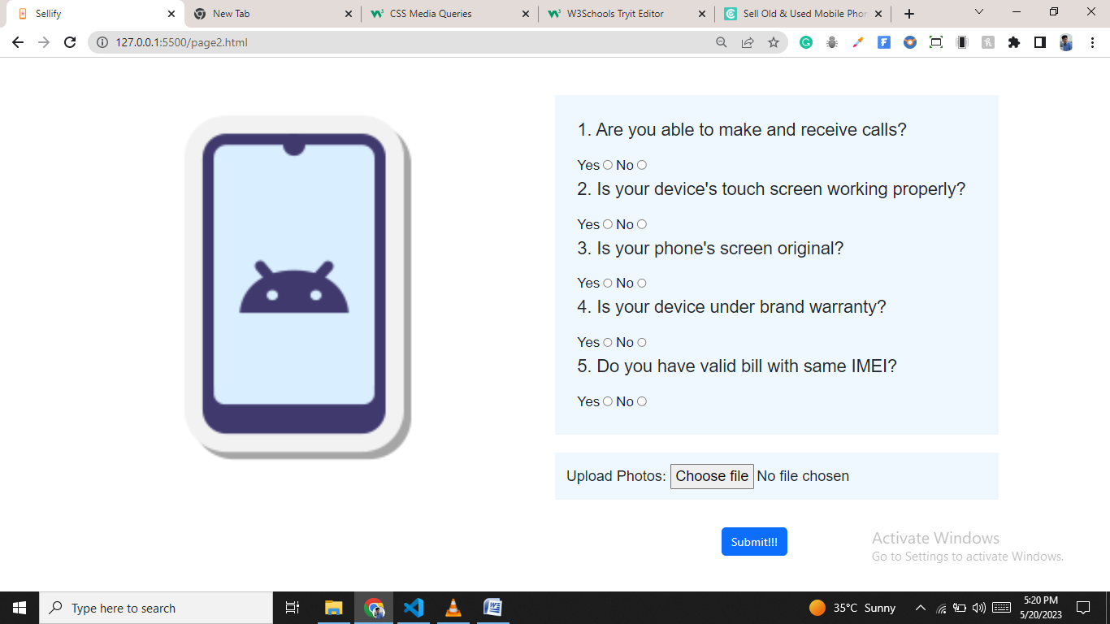

**3.Final Page (Address Page)**

